**Synapse SQL architecture components:**

1. What is Control node :

Answer:  The Control node is the brain of the architecture. It is the front end that interacts with all applications and connections. The distributed query engine runs on the Control node to optimize and coordinate parallel queries. When you submit a T-SQL query, the Control node transforms it into queries that run against each distribution in parallel.

1. What is Compute nodes :

Answer: Each Compute node has a node ID that is visible in system views. You can see the Compute node ID by looking for the node_id column in system views whose names begin with sys.pdw_nodes.

### What is Data Movement Service

Answer: Data Movement Service (DMS) is the data transport technology that coordinates data movement between the Compute nodes. Some queries require data movement to ensure the parallel queries return accurate results. When data movement is required, DMS ensures the right data gets to the right location.

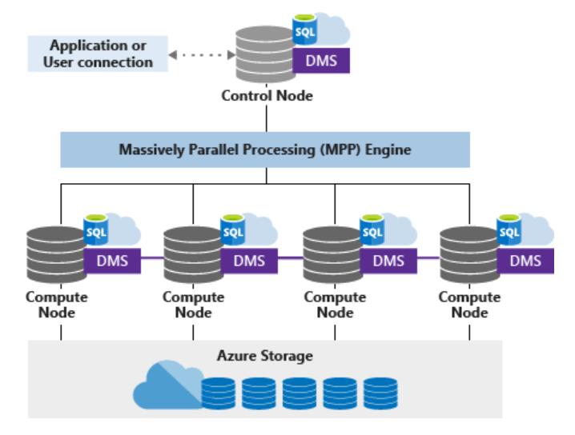

1. Difference between synapse and dedicated sql pool.

Answer :

Synapse is workspace which contains below services :

1. Azure data catalog
2. Azure SQL data ware house
3. ADF
4. Azure data bricks
5. Azure HD insights
6. Azure ML
7. Azure data store lake gen 2
8. Power bi

Dedicated SQL pool is only provide azure sql data warehouse.

NOTE : If you have source as relational database so we will not need synapse services. We can directly load data into azure SQL data ware house.

1. What is server in azure synapse analytics :

Answer: This is just a logical server used to manage group of databases.

It is central administrative point for all databases inside it. Used for changing common settings like logins, firewall, auditing rules, threat detection policy and failover groups for all databases inside it.

If you delete server, it will delete all databases inside that server.

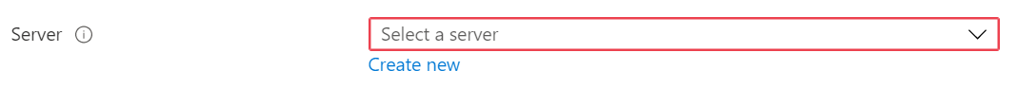

1. What settings we need to do for accessing azure dw from local ssms.

Answer: DO “**Add client IP”** in firewalls and virtual networks.

NOTE: if firewall rule not present then, ssms will ask user to login to azure portal.